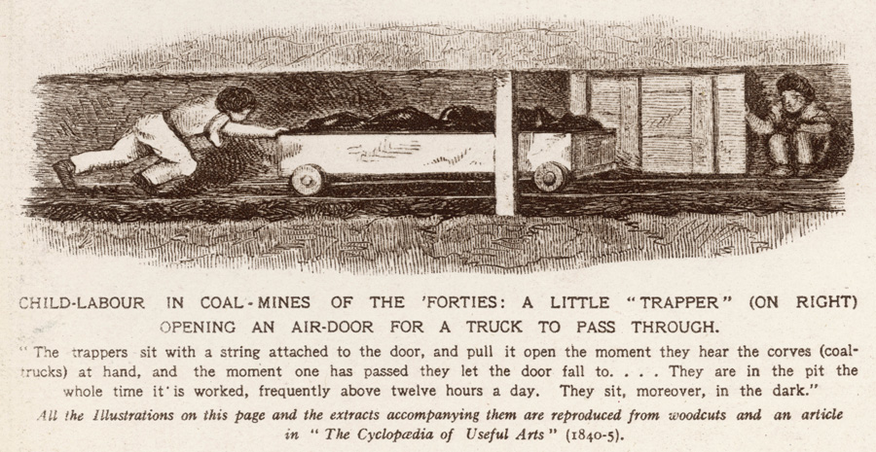**Child Labour in Coal Mines – The Cyclopedia of Useful Arts**